Mill Creek High School Varsity Soccer

Tajay Hoppines Youth Night

Friday, March 7th

Mill Creek vs. Collins Hill
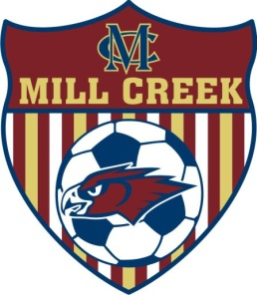

Varsity Girls kick off @ 5:30pm
Varsity Boys kick off @ 7:30pm
Markham Field, 4400 Braselton Hwy, Hoschton, GA

FREE admission to all youth soccer players wearing their team jersey!

The Mill Creek Hawks will "Play for Tajay",
Dedicating Friday's games to Tajay Hoppines.
All proceeds from concession will benefit the Tajay Hoppines Scholarship Fund

